Progress Consortium Meeting at NUSTPB, Bucharest, Romania

It was a great pleasure to have our consortium PHIGO project meeting at “National University of Science and Technology POLITEHNICA, NUSTPB” in Bucharest, ROMANIA on Friday 22nd March 2024.

We are delighted to share the remarkable highlights from the recent PHIGO consortium meeting, hosted at the renowned National University of Science and Technology Politehnica Bucharest.
The esteemed partners presented and discussed the remarkable progress of the PHIGO project aiming to Close the loop for phosphorus (P) and revolutionize sustainable practices. The results reveal an astonishing ability to recover up to 90% of phosphorus from phosphorus-rich ashes. This reclaimed phosphorus not only serves as an invaluable fertilizer but also finds application in various high-value sectors. Simultaneously, the project focuses on transforming residual materials into valuable substances for water treatment and high-strength concrete, utilizing both traditional heating furnaces and cutting-edge microwave techniques for phosphorus recovery.
A pilot-scale fluidized bed combustion system, specially developed and upgraded within the project, now facilitates the conversion of chicken manure into phosphorus-enriched ash, further enhancing the phosphorus recovery process. The reduction process employs a renewable and neutral source of biocarbon, ensuring the elimination of fossil CO2 emissions. Additionally, biogenic CO2 will be harnessed for agricultural purposes. The project's vision extends beyond closing the phosphorus loop; it aims to maximize resource efficiency by recycling residues for valuable applications after phosphorus extraction.
This ambitious endeavor brings together with Swerim a consortium of distinguished experts from the @University of Ege (Turkey), Universidade do Porto (Portugal), National University of Science and Technology Politehnica Bucharest (Romania), Central Mining Institute–National Research Institute and PROGEO (Poland), and University of Brescia (Italy). Generous financial support from ERA-MIN3, Vinnova (Sweden), and various national funders within the European Union and Turkey has made this visionary project possible.
For further details and inquiries, please reach out to the Executive Project Manager, Dr. Elsayed Mousa, and the Project Coordinator from Swerim, Dr. Guozhu Ye.
Join us as we revolutionize sustainable phosphorus recovery and pave the way for a greener future!
PHIGO: Phosphorus Recovery for a Greener Future & Sustainable Society!
hashtag#PHIGOproject hashtag#sustainableInnovation hashtag#resourceefficiency hashtag#greenfuture hashtag#recycling hashtag#CRMs hashtag#reseaech
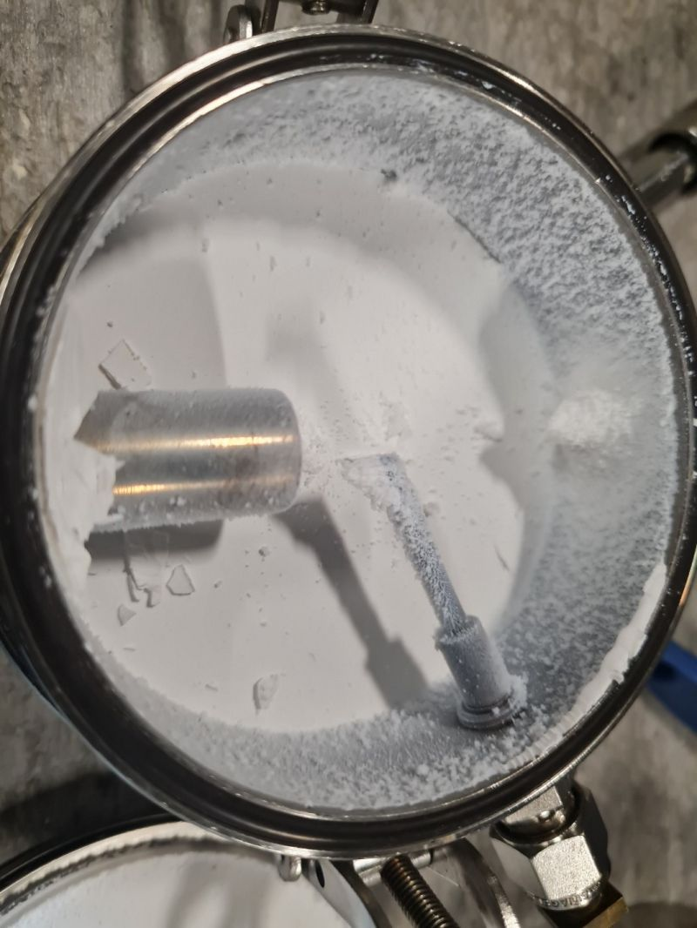
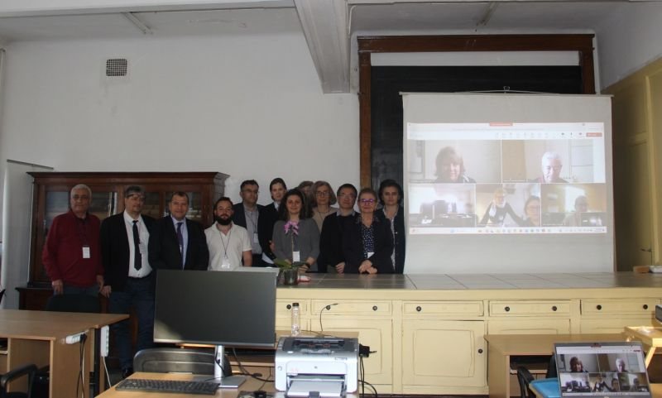
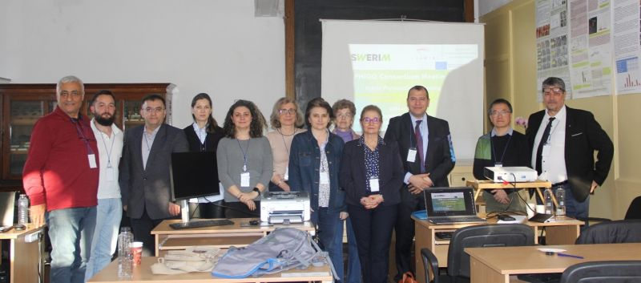
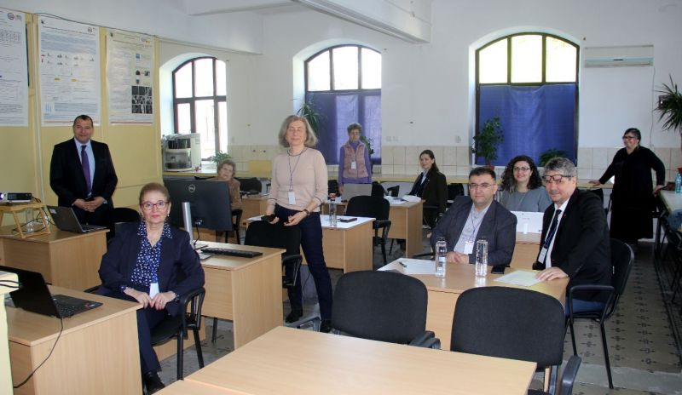
+3

